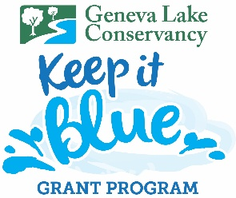
KEEP IT BLUE Grant Program
💧 Up to $5,000 in Funding Available for Homeowner’s Associations or Non-Profit Organizations within 1000 feet from Geneva Lake or identified tributaries.
Funding awarded in $1,000 increments with a 1:1 match required

🌱 Turn Your Shoreline into a Living Asset
Protect Geneva Lake while improving shoreline beauty, stability, and ecological health.
The Keep It Blue Living Shoreline Grant Program supports HOAs and nonprofit organizations located within 1,000 feet of Geneva Lake or its tributaries in creating natural shoreline buffers using indigenous plants that:
✔ Improve water quality
✔ Reduce erosion and shoreline loss
✔ Enhance natural shoreline beauty
✔ Support pollinators and wildlife habitat
✔ Strengthen shoreline resilience

💧 Funding Overview
• Up to $5,000 per project
• Awarded in $1,000 increments
• 1:1 matching funds in $1000 increments
• Reimbursement after project completion
• Limited funding available (first come, first served)

🌼 Why This Matters
Shoreline restoration is one of the most effective tools to:
• Protect healthy water in Geneva Lake
• Reduce nutrient runoff and algae growth
• Prevent erosion and shoreline degradation
• Replace turf grass with thriving native ecosystems

🌊 Eligible Applicants
✔ Homeowners’ Associations (HOAs)
✔ Nonprofit organizations
📍 Must be located within 1,000 feet of Geneva Lake or its tributaries

🪴 How to Apply
- Visit our website: genevalakeconservancy.org/programs
- Review eligibility and program details
- Submit your printed application or email it to cps@genevalakeconservancy.org
- Coordinate project approval and installation timeline

💙 Start at your shoreline and protect Geneva Lake for generations to come.

